

***SMART MONITORING OF WASTE***

***MANAGEMENT USING IOT***

***TEAM MEMBERS:***



* M.LAKSHMI– (9921005308)
* SARATH CHANDRA- (9921005285)

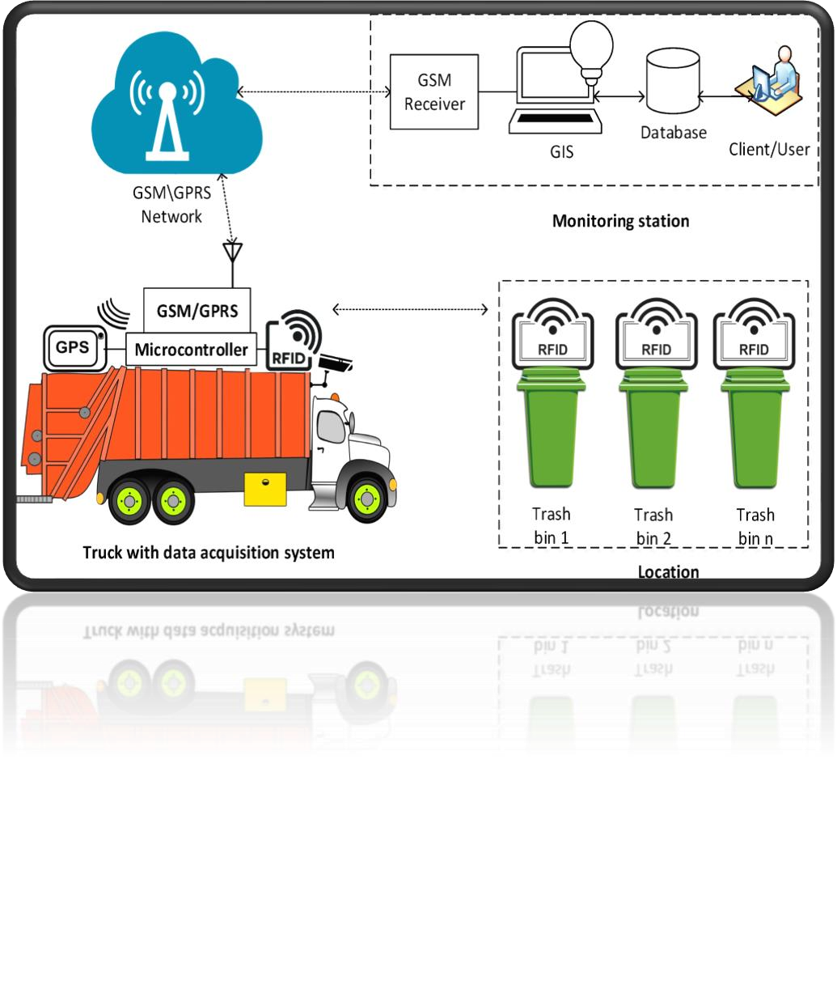

* A.O.SAI CHARAN- (9921009019)
* NETI TEJA–(9921005199)

**Problem statement:** 

* The major problems affecting solid waste management are unscientific treatment,

improper collection of waste and ethical problems. This in turn lead to hazards like

environmental degradation, Water pollution, soil pollution and air pollution.

* Solid waste management is one of the major problems in world. Waste poses a threat

to public health and environment if it is not stored, collected and disposed properly.

**Literature survey :**

**Title :**

SMART MONITORING OF WASTE MANAGEMENT USING IOT.

**Authors:-**

Lilyan Anthony1 , Pradnya Chavan2 , Astrid

Ferreira3 , Prerana Gadhave4 , Archana

Shirke5

**Article name:-** INTERNATIONAL JOURNAL OF ADDVANCED TECHNOLOGY INENGINEERING AND SCIENCE.

ABSTRACT Overflowing garbage bins have been one of the causes of concern for the people in developing countries. With increase in population, the scenario of cleanliness with respect to garbage management is degrading massively. With the already prevailing diseases, the open containers are proving to be a breeding place for germs. The objective of the system is to optimize waste collection and eventually reduce fuel consumption.

|  |  |
| --- | --- |
| **Title :**  SMART MONITORING OF WASTE MANAGEMENT USING IOT. | Essentially, the whole concept is about collecting large amount of waste of material in least amount of time to reduce costs and emissions along the way. Hence, fossil fuel usage can be reduced as optimized routes will be undertaken for collecting garbage and thus transportation cost will also decrease substantially. Additionally, it is supposed to work with any type of container and any type of waste, including mixed materials, paper, glass, metals and fluids. This system can be used in hospitals, colleges universities, industries and various other campuses**.** |

|  |  |
| --- | --- |
| Title:  Smart Monitoring of Waste Management using IoT  Authors:  K.Maheshwaran,  P.S.Alexpandian, A.Anton,  V.Subramaniyan, S.Satheesh  Kumar | Waste management is one of the primary problem that the world faces irrespective of the case of developed or developing country. The key issue in the waste management is that the garbage bin at public places gets overflowed well in advance before the commencement of the next cleaning process. It in turn leads to various hazards such as bad odour & ugliness to that place which may be the root cause for spread of various diseases. To avoid all such hazardous scenario and maintain public cleanliness and health this work is mounted on a smart garbage system. This process is aided by the ultrasonic sensor which is interfaced with Arduino UNO to check the level of garbage filled in the dustbin and sends the alert to the municipal web server once if garbage is filled. |

|  |  |
| --- | --- |
| Title:  Smart Monitoring of Waste Management using IoT | After cleaning the dustbin, the driver confirms the task of emptying the garbage with the aid of RFID Tag. RFID is a computing technology that is used for verification process and in addition, it also enhances the smart garbage alert system by providing automatic identification of garbage filled in the dustbin and sends the status of clean-up to the server affirming that the work is done. The whole process is upheld by an embedded module integrated with RFID and IOT Facilitation. An Android application is developed and linked to a web server to intimate the alerts from the microcontroller to the urban office and to perform the remote monitoring of the cleaning process, done by the workers, thereby reducing the manual process of monitoring and verification**.** |

**Objective of the project:**

➢The main objective of our mini project is to be healthy .

➢By keeping our surrounding clean and neat we can be healthy without any insects

➢So that we have designed a smart garbage, which will give an immediate alarm to workers to clean the region.

➢Then there will be less change to get infected from the insects and will be lead healthy life

**Flow chart:**

start

Garbage bins

sensors

level

Graphical view of

indication

else

Buzzer will on at every

10

%

0

%

-

70

%

%

70

-

100

%

Collections of bins

**Components required:**

* Wifi module
* Jumper wires
* Ardiuno uno board
* Ultrasonic sensor

❑Breadboard

❑Bluetooth module

❑Rainsensor

**Wifi module:**

* The Arduino Uno WiFi is an Arduino Uno with an integrated WiFi module. The board is based on the ATmega328P with an ESP8266WiFi Module integrated. The ESP8266WiFi Module is a self contained SoC with integrated TCP/IP protocol stack that can give access to your WiFi network (or the device can act as an access point).

**Jumper wires:**

* Jumper wires are used for making connections between items on your breadboard and your Arduino's header pins. Use them to wire up all your circuits! Buy jumper wires from Amazon, SparkFun, Adafruit, or Newark.

**Ardiuno uno board:**

* Arduino UNO is a low-cost, flexible, and easy-to-use programmable open-source microcontroller board that can be integrated into a variety of electronic projects. This board can be interfaced with other Arduino boards, Arduino shields, Raspberry Pi boards and can control relays, LEDs, servos, and motors as an output.

**Ultrasonic sensor:**

* It works by sending out a burst of ultrasound and listening for the echo when it bounces off of an object. It pings the obstacles with ultrasound. The Arduino board sends a short pulse to trigger the detection, then listens for a pulse on the same pin using the pulseIn() function.

**Breadboard:**

* A breadboard is a solderless construction base used for developing an electronic circuit and wiring for projects with microcontroller boards like Arduino. As common as it seems, it may be daunting when first getting started with using one.

**Bluetooth module:**

* Introduction. HC-05 Bluetooth Module. HC-05 is a Bluetooth device used for wireless communication with Bluetooth enabled devices (like smartphone). It communicates with microcontrollers using serial communication (USART). Default settings of HC-05 Bluetooth module can be changed using certain AT commands.

**Rainsensor:**

* The rain sensor detects water that comes short circuiting the tape of the printed circuits. The sensor acts as a variable resistance that will change status : the resistance increases when the sensor is wet and the resistance is lower when the sensor is dry.

**Hardware circuit:**

*“taken from google’’*

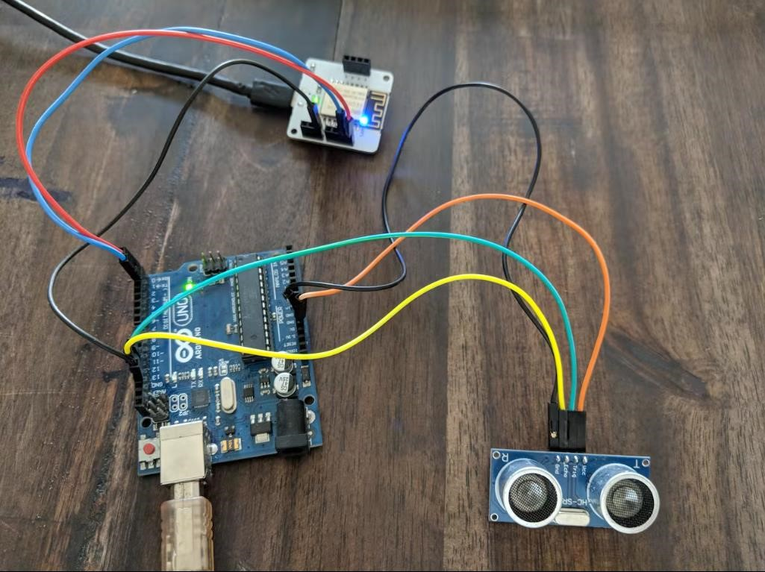

**Result of the project:**

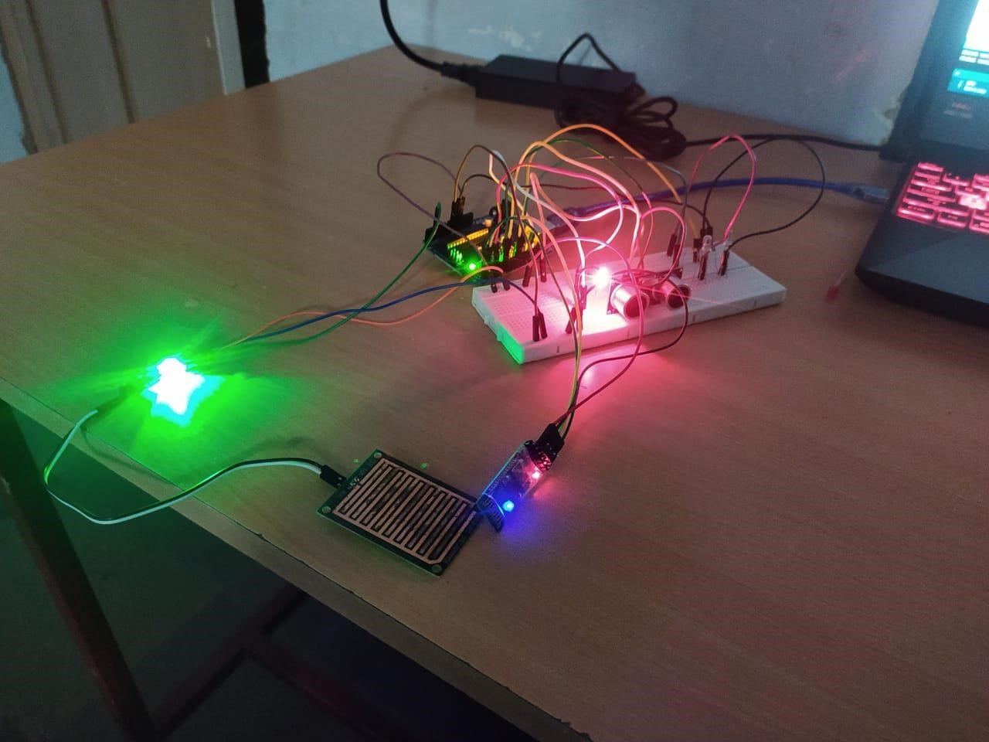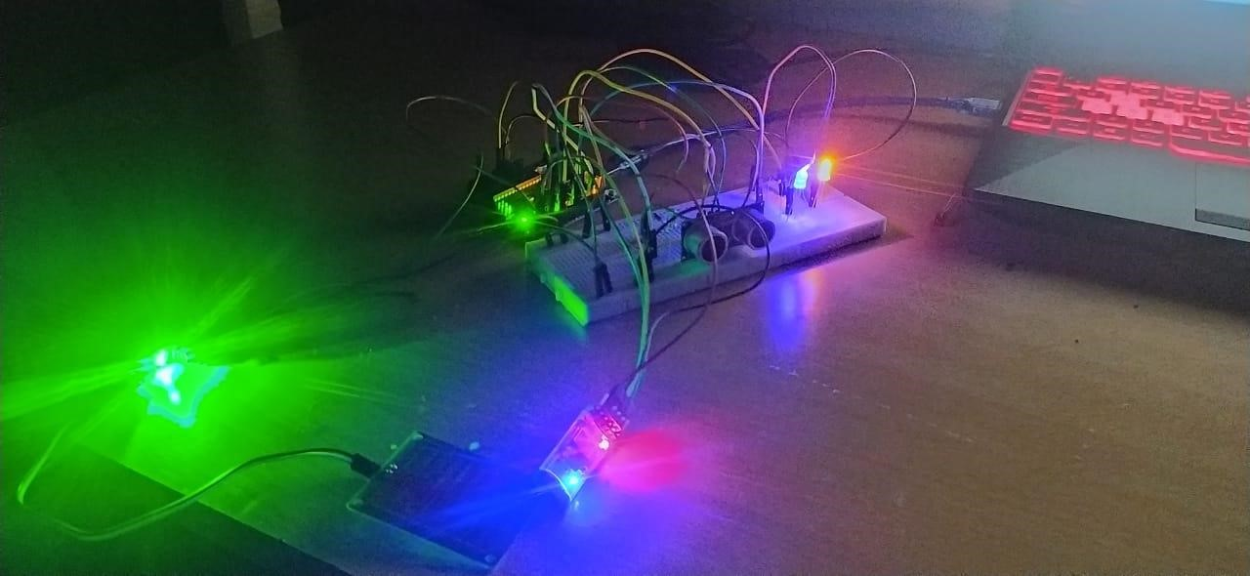

**Circuit diagram:** *“taken from google’’*

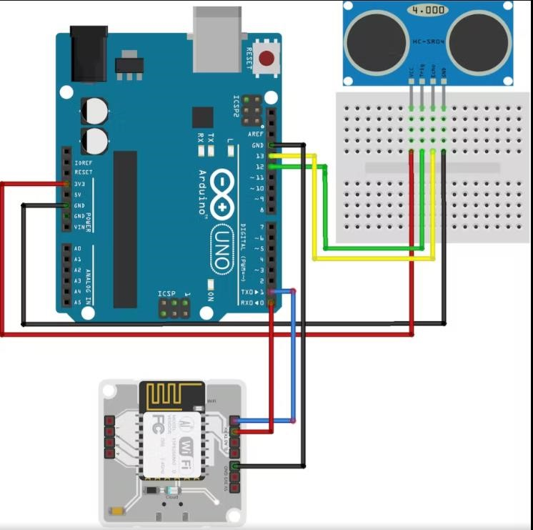

❑The ultrasonic sensor is connected to the Arduino board. The sensors are used to sense the garbage levels once they are placed in the garbage bins.

❑The data collected by the sensors is communicated via Bluetooth which is also connected to the Arduino Uno board.

❑The data that is collected is sent to the admin for analysis and is monitored by the admin through the web application. The sensor input is given to sensor monitoring module, then to the communication module.

❑ Based on the information that is communicated, analysis and monitoring are done. The sensor input is processed in the sensor monitoring module. This data is transferred to the communication module through Bluetooth.

❑The Bluetooth receiver will then receive the information and give it to the webpage. Based on the levels of garbage in the bins which are displayed on the web page, notification will be generated.

❑The sensor input is processed in the sensor monitoring module. This data is transferred to the communication module through Bluetooth.

❑The Bluetooth receiver will then receive the information and give it to the webpage. Based on the levels of garbage in the bins which are displayed on the web page, notification will be generated.

❑The GSM module will then transmit the message to the garbage vehicle driver. The Admin will login to the webpage and the dashboard will open. He will be authenticated to the system. The webpage will show the status of the bins.

❑Based on the requirements analysis and monitoring will be done. If the bins are full trigger will be generated. The SMS also gets generated, which will be sent to the vehicle driver. Thus the driver will collect the overflowing garbage.

**Smart Monitoring And Controlling Hut :**

* The Smart Monitoring and controlling Hut is a centrally
* controlling hub for all the smart functioning of this
* management system. This is the heart of the entire system and
* always takes signals as input from the local base stations
* spread over an area. It is the signal from the local base
* stations that invokes the controlling hut to make a decision
* about the management of waste of some particular trash bin.

**ADVANTAGES:**

Automatic garbage level detection prevents overflow.

* It also aids in the effective management of waste. Once installed, the maintenance cost of the system is low.
* Deployment of dustbin based on the actual needs.
* In addition, there is also the provision to alter the receptors of the message, when required
* A reduction in the no.of waste collections needed by up to 80% resulting in less man power
* Emission ,fuel use and traffic congection.
* A reduction in the no.of waste bins needed.
* Analytics the data to manage collections, routes and the placement of bins more effectively.

**DIS-ADVANTAGES:**

❑System requires more no.of waste bins for separate waste collections as per population in the city.

❑Sensor nodes used in the dustbins have limited memory sizes.

❑The training as to be provided to be people involved in the smart waste management system

❑To prevent any sort of tampering of the system by the public when kept in the open.

❑Disposed large-sized waste objects may obstruct the signals resulting in error messages.

*program code:*

#define Trigpin 7

#define Echopin 8

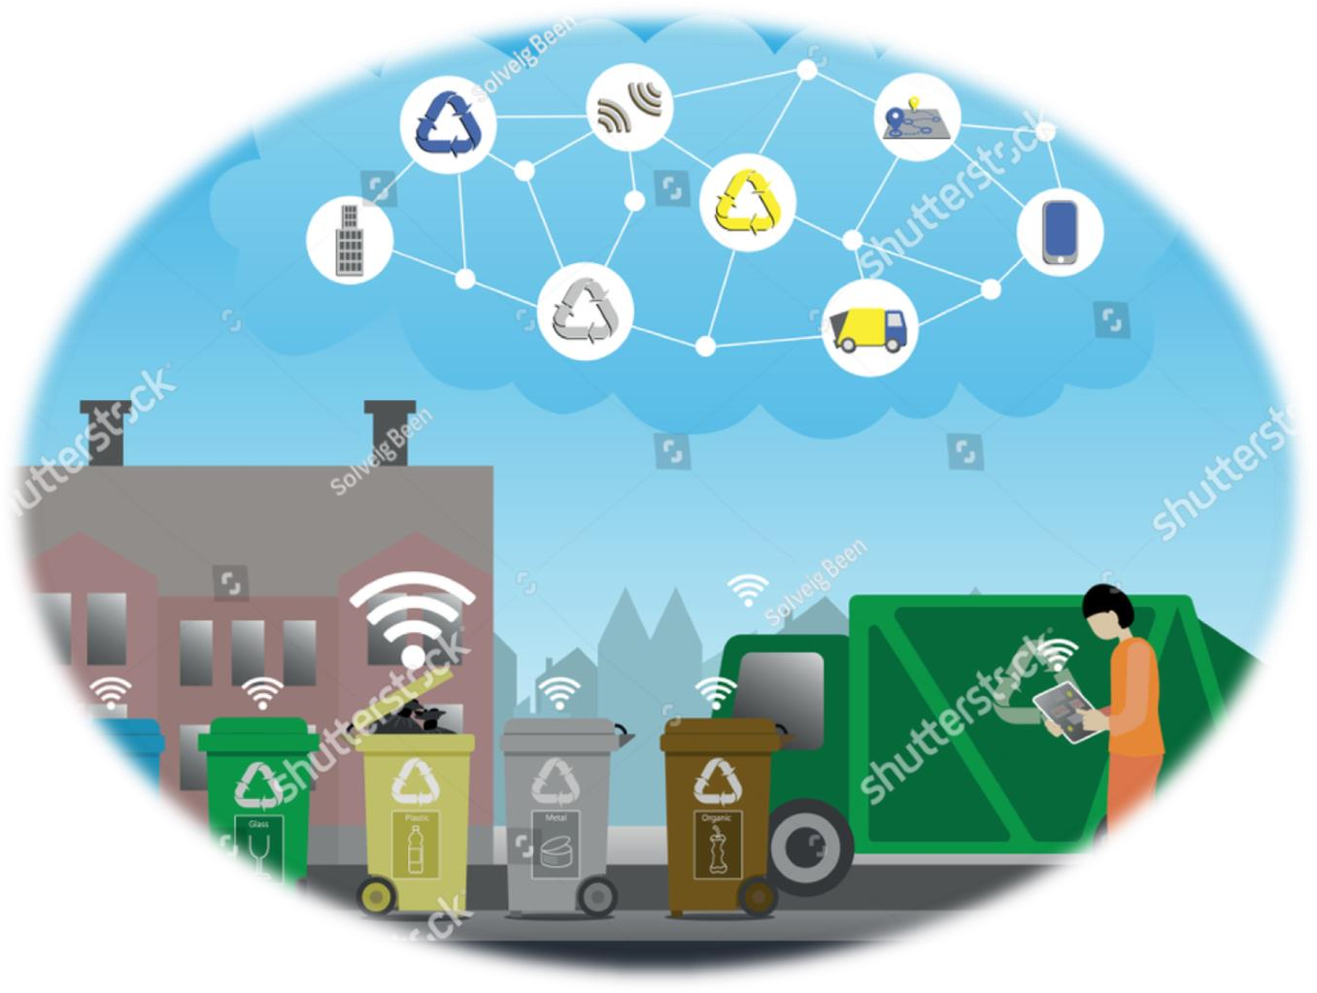#define low_led 9 #define high_led 10 float distance; int duration; int ll = 700;

void setup() {

pinMode (Trigpin, OUTPUT); pinMode (low_led, OUTPUT); pinMode (high_led, OUTPUT); pinMode (Echopin, INPUT);

Serial.begin(9600);

Serial.println ("Welcome To Distance Meter"); Serial.println ("Coded By ganesh"); digitalWrite (low_led, LOW); digitalWrite (high_led, LOW);

• }

void loop() {

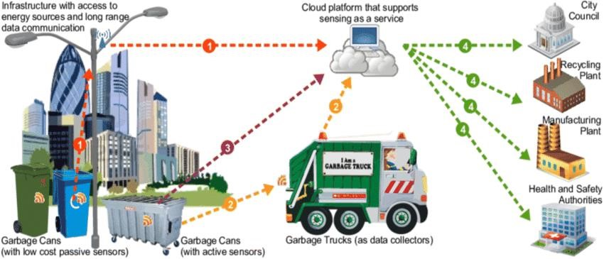digitalWrite(Trigpin, LOW); delayMicroseconds(2); digitalWrite(Trigpin, HIGH); delayMicroseconds(10); digitalWrite(Trigpin, LOW); duration = pulseIn(Echopin, HIGH); distance = duration * 0.034 / 2; delay (ll); Serial.println (" ");

Serial.print ("Distance = ");

Serial.print (distance);

Serial.print (" CM"); Serial.println (" ");

if (distance<3)

{

Serial.println ("Nobody Is Infront Of the Sensor"); digitalWrite (low_led, HIGH);

delay (500); digitalWrite (low_led, LOW); delay (500);

digitalWrite (low_led, HIGH);

} else ;

{

Serial.println ("Someone Is Infront Of the Sensor"); digitalWrite (high_led, HIGH); delay (100); digitalWrite (high_led, LOW); delay (100); digitalWrite (high_led, HIGH); delay (100);

}

}

* void setup() {
* Serial.begin(9600);//enable serial monitor
* pinMode(4, OUTPUT);//define LED pin
* }
* void loop() {
* int value = analogRead(A3);//read value
* Serial.print("Value : ");
* Serial.println(value);
* if (value < 300) {//check condition
* digitalWrite(4, HIGH);
* Serial.print("rain is coming remove dust ");
* } else {
* digitalWrite(4, LOW);
* }
* }

**News articles on garbage:**

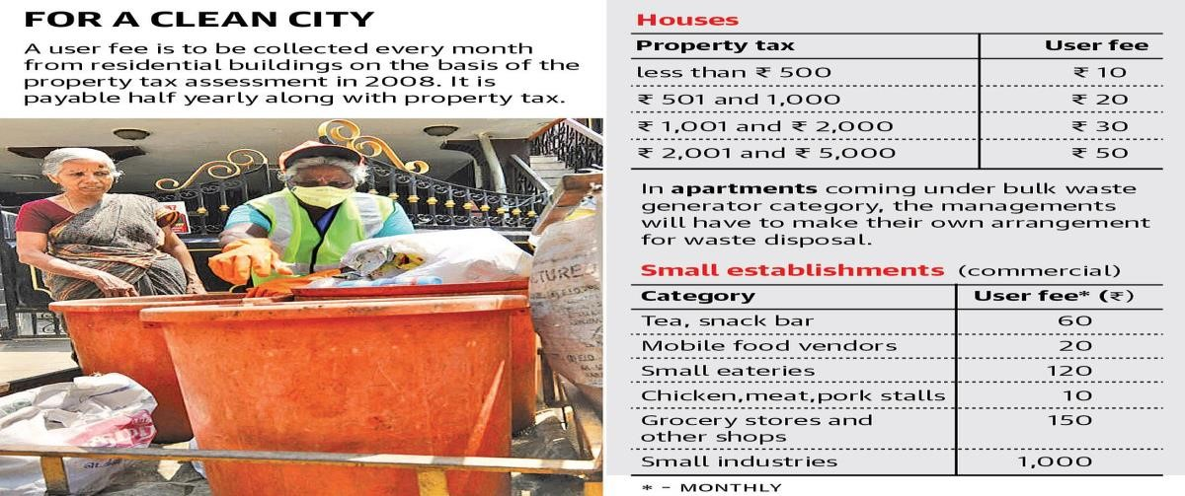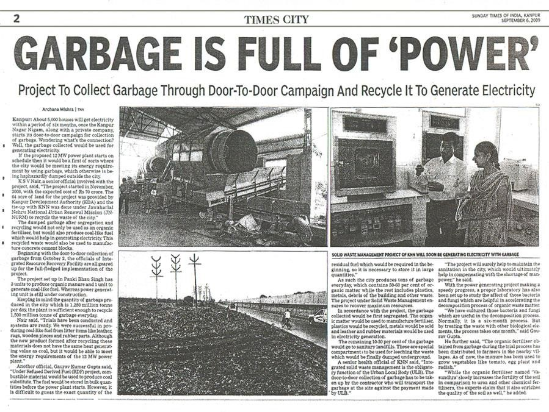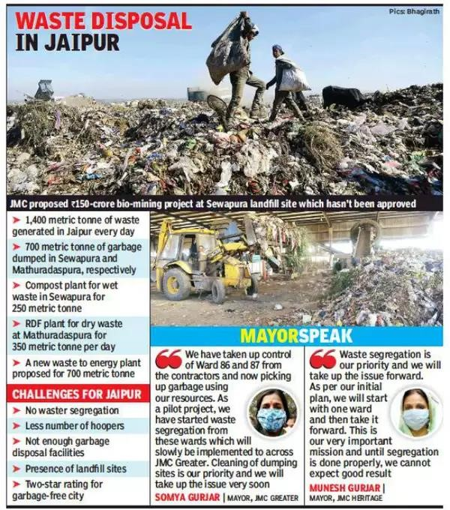

**Reference:**

* [https://www.google.com/search?q=rain+sensor+arduino&ei=TSg9Y4PaAaSL4-EPrr21Ac&ved=0ahUKEwjDtMWBv8j6AhWkxTgGHa5eDX8Q4dUDCA4&uact=5&oq=rain +sensor+arduino&s_lcp=Cgd](https://www.google.com/search?q=rain+sensor+arduino&ei=TSg9Y4PaAaSL4-EPrr21-Ac&ved=0ahUKEwjDtMWBv8j6AhWkxTgGHa5eDX8Q4dUDCA4&uact=5&oq=rain+sensor+arduino&s_lcp=Cgd)
* [https://www.google.com/search?q=smart%20garbage%20monitoring%20system%20usi ng%20arduino&tbm](https://www.google.com/search?q=smart%20garbage%20monitoring%20system%20using%20arduino&tbm)
* [https://www.rcciit.org/students_](https://www.rcciit.org/students_projects/projects/it/2018/GR24.pdf)
* [projects/projects/it/2018/GR24.pdf](https://www.rcciit.org/students_projects/projects/it/2018/GR24.pdf)
* system architecture diagram.pdf
* project pdf online.pdf

